GST FAI 4-2015
NO. | ISSUES | RMC DECISION | MEMBERS COMMENTS
1. | Local company (LC) purchased goods from overseas supplier (OS) and later sold the goods to local buyer (LB) and issue an invoice (local invoice). The LC requests the overseas supplier to deliver the goods direct to his local buyer (LB).  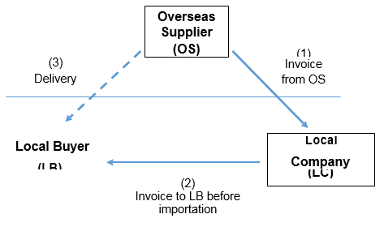  Whether the supply made by LC to LB subject to GST? | The supply made by LC to LB will qualify for an out of scope supply, subject to compliance with the following conditions -  - There is proof that the transfer of ownership of the goods took place outside Malaysia before the goods are imported into Malaysia (through shipping document or incoterm);  - The import declaration was in the name of LB and the value of the imported goods was based on the local invoice which stated that the goods are originated from OS;  - LC must keep and maintain the following documents –  - Purchase order from LC to OS;  - Invoice from OS to LC;  - Tax invoice issued by LC to LB stated that the goods are originated from OS;

GST FAI 4-2015
NO. | ISSUES | RMC DECISION | MEMBERS COMMENTS
  - Written instruction from LC to OS that the purchase goods is to be exported to LB; and
  - Proof of payment from LC to OS and from LB to LC;
- LB must keep and maintain the following documents –
- Purchase order from LB to LC;
- Tax invoice issued by LC to LB;
- Proof of payment from LB to LC;
- Import declaration form under LB’s name as consignee;
- Bill of lading / airway bill stating the following details:
(aa) OS as the shipper;
(bb) LB as the consignee;
(cc) LC as a notify party.
- Any other necessary conditions as the Director General may require from time to time.

GST FAI 4-2015
NO. | ISSUES | RMC DECISION | MEMBERS COMMENTS
2. | Local company (LC) purchased goods from a local manufacturer (LM) and request LM to export the goods to his overseas buyer (OB).  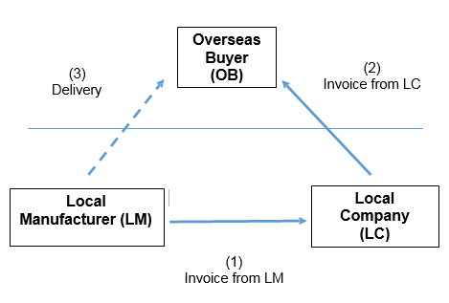  Whether the supply made by LM to LC qualify for a zero rate? | - The supply of goods made by LM to LC is a standard rated supply, because the transfer of ownership of the goods took place in Malaysia. However such supply will qualify for a zero rate subject to compliance with the following conditions –  - The supply is related to goods other than wine, spirit, beer, intoxicating liquor, malt liquor, tobacco and tobacco products;  - LM must keep and maintain the following documents –  - Purchase order from LC to LM;  - Tax invoice issued by LM to LC and shipped to OB  - Written instruction from LC that the purchase goods is to be exported to OB  - Proof of payment from LC to LM
GST FAI 4-2015
NO. | ISSUES | RMC DECISION | MEMBERS COMMENTS
2. |  | - Export document such as K2/K8 where it is stated that the consignor is LM and the consignee is OB; and  - Bill of lading / airway bill stating the following details:  (aa) LM as the shipper;  (bb) OB as the consignee; and  (cc) Indicate under column “Notify Party” the details of OB or his representative and LC as the owner of the goods.  - LM must export the goods within 60 days or any extended period as approved by the Director General (DG) from the time of supply;  - Time of supply for LM is the date of invoice issued or payment received, whichever is the earlier;
GST FAI 4-2015
NO. | ISSUES | RMC DECISION | MEMBERS COMMENTS
(e) The local company (LC) must keep and maintain the following documents –
- Purchase order from OB to LC;
- Invoice issued by LC to OB; and
- Proof of payment from OB to LC;
AND
- Any other necessary conditions as the Director General may require from time to time.
- If LM does not have possession of the goods to be exported or control over the export arrangement he must treat the sales as local supply and subject to GST at standard rate.

GST FAI 4-2015
NO. | ISSUES | RMC DECISION | MEMBERS COMMENTS
3 | Local company (LC) sell goods to overseas buyer (OB 1) and OB1 request the goods to be delivered to his local agent (LA) in PCA and subsequently the goods are exported out by LA to OB1 customer’s in other countries (OB2).  Whether the supply made by LC to OB1 can qualify for a zero rate? | - The supply of goods made by LC to OB1 is subject to GST at standard rate and not qualify for zero rate as the goods were delivered into PCA.  - The goods exported by LA to OB2 are zero rated supply with conditions that the export form Customs No.2 and shipping documents indicated that the consignor is LA and the consignee is OB2.
GST FAI 4-2015
NO. | ISSUES | RMC DECISION | MEMBERS COMMENTS
4 | Local supplier (LS) sell goods to overseas buyer (OB) and the OB request the goods to be delivered to the third party (TP) in the Free Commercial Zone (FCZ) for value added activity or consolidation.  The third party refers to any agent appointed by the OB.  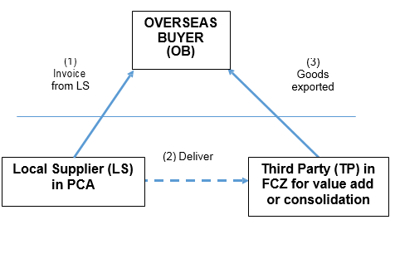  Whether the supply made by LS to OB qualify for a zero rate? | - Such supply of goods to the overseas buyer (OB) will qualify for a zero rate subject to compliance with the following conditions –  - The supply is related to goods other than wine, spirit, beer, intoxicating liquor, malt liquor, tobacco and tobacco products;  - LS must prove that the goods is physically removed into FCZ and sent to TP;  - LS must keep and maintain the following documents –  - Invoice issued to the overseas buyer;  - Export, transit and other related documents such as customs forms and shipping documents as required under the customs legislation; and
GST FAI 4-2015
NO. | ISSUES | RMC DECISION | MEMBERS COMMENTS
    - Written instruction/agreement by the overseas buyer to send the goods to a third party in the FCZ for value added activity or consolidation.
  - TP must keep and maintain the following documents –
- Export documents such as invoices, customs forms, free zone forms and shipping documents to prove that the goods have been physically exported overseas; and
- Other related documents received from the supplier.
AND
(e) Any other necessary conditions as the Director General may require from time to time.
- If the goods are not exported physically overseas, TP is liable to account the GST at a standard rate.
GST FAI 4-2015
NO. | ISSUES | RMC DECISION | MEMBERS COMMENTS
5 | Local supplier (LS) sell goods to overseas buyer (OB) and the OB request the goods to be delivered to the third party (TP) in the licensed warehouse (LW) for value added activity or consolidation.  The third party refers to any agent appointed by the overseas buyer.  Whether the supply made by LS to OB qualify for a zero rate? | - Such supply of goods to the overseas buyer (OB) will qualify for a zero rate subject to compliance with the following conditions:  - The supply is related to goods other than wine, spirit, beer, intoxicating liquor, malt liquor, tobacco and tobacco products;  - LS must prove that the goods are physically removed into LW and sent to TP;  - LS must keep and maintain the following documents –  - Invoice issued to OB;  - Export, transit and other related documents such as customs forms and shipping  documents as required under the customs legislation; and
GST FAI 4-2015
NO. | ISSUES | RMC DECISION | MEMBERS COMMENTS
(iii) Instruction/agreement by OB to send the goods to a third party in the LW for value added activity or consolidation.
- TP must keep and maintain the following documents –
  - Export documents such as invoices, customs forms and shipping documents to prove that the goods has been physically exported overseas; and
  - Other related documents received from the supplier;
AND
- Any other necessary conditions as the Director General may require from time to time.
- The goods removed from the LW must be exported directly to overseas.
- If the goods are not exported physically overseas, TP is liable to account the GST.
GST FAI 4-2015
NO. | ISSUES | RMC DECISION | MEMBERS COMMENTS
6. | What is the GST treatment for goods manufactured locally which is supplied or sold by a local supplier to an overseas buyer but the goods are in the possession of the supplier and subsequently released for export in stages as instructed by the overseas buyer? | (1)Such supply of goods will qualify for a zero rate subject to compliance with the following conditions –  - The supply is related to goods other than wine, spirit, beer, intoxicating liquor, malt liquor, tobacco and tobacco products;  - The supplier must issue invoice before the goods are exported to the overseas buyer;  - The time of supply will be invoice issued or payment received whichever is the earlier;  - The goods are physically exported within 60 days from the time of supply or any extended period as approved by the Director General (DG);  - The supplier must export the goods in his name through his appointed freight forwarder or through his overseas buyer’s appointed freight forwarder;
GST FAI 4-2015
NO. | ISSUES | RMC DECISION | MEMBERS COMMENTS
- The supplier must keep and maintain the following documents –
  - Agreement with the overseas buyer which shows that they agreed to such transaction;
  - The export, transit and other related documents such as customs forms and shipping documents as required under the customs legislation;
  - Purchase order from overseas buyer to the supplier;
  - Supplier’s sale invoice to overseas buyer; and
  - Any other records as the DG may determine.
AND
- Any other necessary conditions as the Director General may require from time to time.
GST FAI 4-2015
NO. | ISSUES | RMC DECISION | MEMBERS COMMENTS
- If the goods are not exported physically overseas within 60 days from the time of supply or any extended period as approved by the Director General (DG), the supply to the overseas buyer is a standard rated supply and the supplier has to account the GST at a standard rate.
- The supplier will not qualify for zero rating if he does not have in his possession the goods to be exported or does not have control over the export arrangement.

GST FAI 4-2015
NO. | ISSUES | RMC DECISION | MEMBERS COMMENTS
7. | What is the GST treatment on non-recurring expenditure (NRE) and other manufacturing expenditure connected to manufacture goods to be exported overseas?  The non-recurring expenses (relating to goods) incurred are for the purchase of moulds, dies, tooling, jigs, fixtures and related equipment used specifically for overseas buyer (OB) in the contract manufacturer’s (CM) premises. | (1) The non-recurring expenses (NRE) incurred for the purchase of moulds, dies, tooling, jigs, fixtures and related equipment used specifically for overseas buyer (OB) in the contract manufacturer’s (CM) premises is not subjected to GST if the cost recovery does not include any element of value add.  Example – purchase of mould by CM is RM100,000 and the recovery from the OC is also RM100,000 hence such cost recovery is not subject to GST.  - The treatment above is subject to compliance with the following conditions –  - Ownership of NRE must be OC and not to be accounted as asset by CM;  - Must have a written agreement/contract between CM and OC regarding the NRE and the exportation of manufactured goods;
GST FAI 4-2015
NO. | ISSUES | RMC DECISION | MEMBERS COMMENTS
- The NRE relating to the purchased goods are used wholly to manufacture goods to be exported to overseas buyer;
- NRE are incurred to manufacture goods according to specifications by OC;
- The CM keeps and maintain export and other related documents such as Customs No.2/8 forms, airway bill, manifest, invoice, purchase order, payment records, etc.;
- When the moulds, dies, tooling, jigs, fixtures and related equipment and its components are no longer to be used as specified in the contract, these goods must be returned to the OC. If such goods are disposed locally, it is subject to GST at standard rate;
AND
- Any other necessary conditions as the Director General may
GST FAI 4-2015
NO. | ISSUES | RMC DECISION | MEMBERS COMMENTS
 |  | require from time to time.

