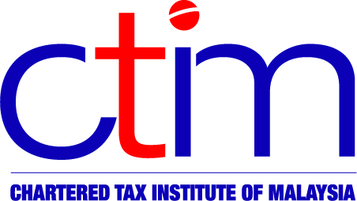
e-CIRCULAR TO MEMBERS

Chartered Tax Institute of Malaysia (225750-T)
e-CTIM TECH-DT 63/2015 19 August 2015

TO ALL MEMBERS

TECHNICAL

Direct Tax
INCOME TAX (DEDUCTION FOR PRE-COMMENCEMENT EXPENSES IN RELATION TO REFINERY AND PETROCHEMICAL INTEGRATED DEVELOPMENT) (AMENDMENT) RULES 2015 [P.U. (A) 183/2015]
The above Rules was gazetted on 13 August 2015 and amends the Income Tax (Deduction for Pre-commencement Expenses in relation to Refinery and Petrochemical Integrated Development) Rules 2013 [P.U. (A) 43/2013] (referred to below as “the original Rules”).
Subrule 3(2) of the original Rules is amended by substituting the word “four” with the word “seven” as follows:
(2) The expenses referred to in subrule (1) as specified in the Schedule shall be incurred within four seven years prior to the date of commencement of the qualifying activity and that date shall not be earlier than 1 October 2010.
In other words, the time span for incurrence of expenses which qualify for deduction under the original Rules has been extended to 7 years prior to the date of commencement of the qualifying activity, from 4 years prior to that date. (The date of commencement of the qualifying activity must not be earlier than 1 October 2010.)
The amendment is deemed to have effect from the year of assessment 2010.

Members may read the Rules in full at the official website of Attorney-General’s Chambers.

Disclaimer

This document is meant for the members of the Chartered Tax Institute of Malaysia (CTIM) only. CTIM has taken all reasonable care in the preparation and compilation of the information contained in this E-CTIM. CTIM herein expressly disclaims all and any liability or any liability or responsibility to any person(s) for any errors or omissions in reliance whether wholly or partially, upon the whole or any part of this E-CTIM.

