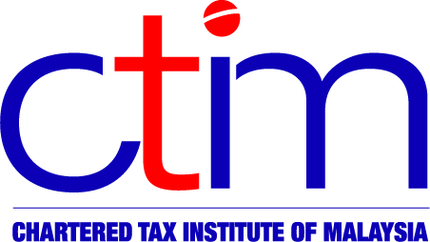

CTIM EXAMINATION TIMETABLE

02 – 06 DECEMBER 2013

Time | 02 / 12 / 2013  (Monday) | 03 / 12 / 2013  (Tuesday) | 04 / 12 / 2013  (Wednesday) | 05 / 12 / 2013  (Thursday) | 06 / 12 / 2013  (Friday)
9.00 AM  – 12.10 PM * | Personal Taxation (Taxation I) | Business Taxation (Taxation II) | Specialised Industries (Taxation III) | Revenue Law (Taxation IV) | Advance Taxation (Taxation V)
2.00 PM  – 5.10 PM * | Company & Business Law | Business & Financial Management | Financial Accounting II | Economics & Business Statistics | Financial Accounting I

* Includes 10 minutes of reading time.

