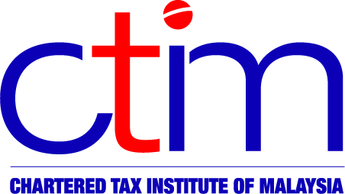
e-CIRCULAR TO MEMBERS

Chartered Tax Institute of Malaysia (225750-T)

(formerly known as Malaysian Institute of Taxation)

e-CTIM No.47/2009 2 October 2009

TO ALL MEMBERS

TECHNICAL

Indirect Taxation

- Customs (Amendment)(No.4) Regulations 2009 [P.U.(A) 313-2009]

Regulation 11A and Part I of Second Schedule of Customs Regulations 1977 have been amended and are effective from 27 August 2009. Form Customs No. 1A (Value Declaration Form) is to be completed and submitted together with form Customs No. 1 if the invoice value of imported goods for any one consignment is RM 20,000 or more, the imported goods are for commercial purposes and the import duty is levied on the goods.
- List Of Taxable And Non-Taxable Services For The Purposes Of Service Tax

The Royal Customs Malaysia (RCM) has, on 14 September 2009, issued a “List of Taxable and Non-taxable Services for the Purposes of Service Tax”. The list indicates the types of taxable and non-taxable services for the various industries/service providers such as accountants, private hospitals, hotels, parking operators, lawyers, consultants, restaurants, telecommunications companies, etc.

The RCM has indicated that the list is to be used only as a guide and should not be taken as conclusive when making decisions. You may obtain further clarification/details from the RCM at 03-8882 2100 (telephone), 03-8889 5869 (fax) or e-mail cd@customs.gov.my.

Members may view the detailed guide at the RCM’s website at http://www.customs.gov.my/documents/Bahagian%20CD/Senarai%20perkhidmatan%20bercukai%20dan%20tidak%20bercukai.pdf or the Institute’s website at http://www.ctim.org.my/technical_techdev_indirect.asp

PUBLICATION

2010 Budget Commentary and Tax Information

Members who wish to purchase additional copies of the 2010 Budget Commentary & Tax booklet are requested to complete the order form , and return it with the appropriate remittance to the CTIM Secretariat by October 9, 2009. For the order form, kindly click on :

http://www.ctim.org.my/cms/BB10_Order%20Form(CTIM).pdf

For queries or feedback on the CTIM e-circular, please email communications@ctim.org.my.

Disclaimer
Although the Chartered Tax Institute of Malaysia (formerly known as Malaysian Institute of Taxation) has taken all reasonable care in the preparation and compilation of the information contained in the CTIM e-circular, the Institute / each party providing the material displayed herein expressly disclaim all and any liability or responsibility to any person(s) for any errors or omissions in the contents of the CTIM e-circular or for anything done or omitted to be done by any such person in reliance whether wholly or partially, upon the whole or any part of the contents of the CTIM e-circular.

