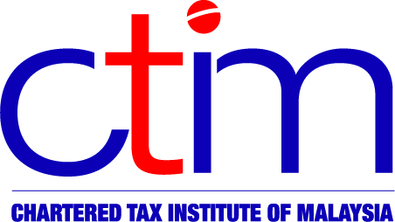
e-CTIM TO STUDENTS

Chartered Tax Institute of Malaysia (225750-T)

e-CTIM STU 4/2016
9 September 2016

TO ALL STUDENTS

A. NOTICE OF DECEMBER 2016 EXAMINATIONS DATES

- The closing date for registration for the December 2016 CTIM Examination is Friday 14 October 2016.

- The examination registration/entry form have been sent to all students by post. If you have not received the examination registration/entry form by 30th September 2016, contact the Examination Department at 21628989 Ext 109, 110 or 111 for assistance.

- The examination time table is set out below: CTIM EXAMINATION TIMETABLE

19 - 22 DECEMBER 2016

Time | 19 / 12 / 2016  (Monday) | 20 / 12 / 2016  (Tuesday) | 21 / 12 / 2016  (Wednesday) | 22 / 12 / 2016  (Thursday)
9.00 AM  – 12.10 PM * | Company & Business Law | Revenue Law | Advance  Taxation 1 | Advance  Taxation 2
2.00 PM  – 5.10 PM * | Personal Taxation | Business Taxation | Financial Accounting | Economics

* Includes 10 minutes of reading time
Note:

For Personal Taxation and Business Taxation papers, candidates are allowed to bring the Income Tax Act 1967 (Amended) as reference during the examination.

- For Revenue Law, Advanced Taxation 1 and Advanced Taxation 2 papers, candidates are allowed to bring the following Acts as reference during the examination:-

Income Tax Act 1967 (Amended)

Real Property Gains Tax Act 1976 (Amended)

Goods and Services Act 2014 (Amended)
- Stamp Act 1949 (Amended)

(Note: The above acts should be clean copies; copies that contain written notes or quotation of case laws are disallowed)

- Questions for the December 2016 examinations will be based on laws that include the Finance Act 2015, Public Rulings and Gazette Orders issued up to 31 December 2015.

- Question may be set based on reference to recent articles and case law published in the Tax Guardian.

B. CHANGE TO CONTENT STRUCTURE OF COMPANY & BUSINESS LAW PAPER FROM JUNE 2017 EXAMINATIONS ONWARDS

The content structure of the Company and Business Law paper (CBL) will be changed from June 2017 examination onwards. The CBL paper will consist of 2 sections, A & B. Section A will consist of Company Law, Section B will consist of Business Law. Each of these sections will have 3 questions each. Candidate will need to answer a total of 5 questions. 2 questions in Section A and 2 questions in Section B and the fifth question from either of the 2 sections.

Disclaimer
This document is meant for students of the Chartered Tax Institute of Malaysia (CTIM) only. CTIM has taken all reasonable care in the preparation and compilation of the information contained in this E-CTIM; the Institute herein expressly disclaims all and any liability or responsibility to any person(s) for any errors or omissions in reliance whether wholly or partially, upon the whole or any part of this E-CTIM.

