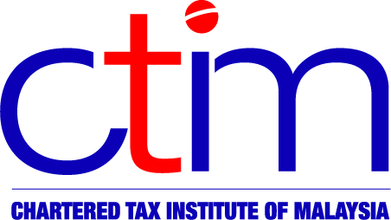
E-CTIM TO STUDENTS

Chartered Tax Institute of Malaysia (225750-T)

E-CTIM STU 3/2017 9 June 2017

Changes to CTIM examination syllabus

The Institute is pleased to inform all CTIM students that the Examination syllabus for all subjects for the CTIM Professional Examinations has been reviewed and amended to incorporate changes in the rules and legislation.

The new examination syllabus will be effective from the December 2017 examinations.

The revised examination syllabus is available for download from the CTIM website www.ctim.org.my in the Education section.

Disclaimer

This document is meant for students of the Chartered Tax Institute of Malaysia (CTIM) only. CTIM has taken all reasonable care in the preparation and compilation of the information contained in this E-CTIM; the Institute herein expressly disclaims all and any liability or responsibility to any person(s) for any errors or omissions in reliance whether wholly or partially, upon the whole or any part of this E-CTIM.

