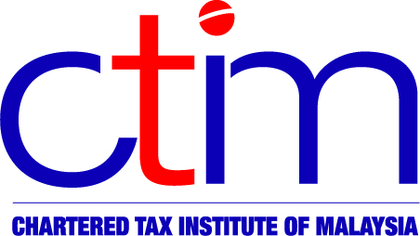
e-CIRCULAR TO MEMBERS

Chartered Tax Institute of Malaysia (225750-T)

CTIM No.166/2012 9 November 2012

TO ALL MEMBERS

TECHNICAL

IRB Media Release – Re-Branding of Inland Revenue Board’s Contact Centre Toll- Free Line

Please be informed that the toll-free line 1-300-88-3010 of the Inland Revenue Board (IRB) has been replaced by 1-800-88-LHDN (5436). The toll-free line is for general inquiries about income tax matters.
With regard to any assistance or clarification on the 1 Malaysia People’s Aid (BR1M), members may contact 1-800-88-BR1M (1-800-88-2716). The BR1M_2.0 Form is linked for your convenience. For more information, members may visit https://ebr1m.hasil.gov.my .
The IRB Media Release may be viewed at the CTIM website or the IRB website.

Disclaimer
Although the Chartered Tax Institute of Malaysia has taken all reasonable care in the preparation and compilation of the information contained in the CTIM e-circular, the Institute / each party providing the material displayed herein expressly disclaim all and any liability or responsibility to any person(s) for any errors or omissions in the contents of the CTIM e-circular or for anything done or omitted to be done by any such person in reliance whether wholly or partially, upon the whole or any part of the contents of the CTIM e-circular.

