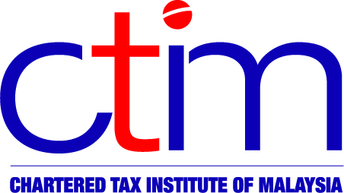
e-CIRCULAR TO MEMBERS

Chartered Tax Institute of Malaysia (225750-T)

e-CTIM BR KL 1/2013 (Reminder) 25 March 2013

TO ALL MEMBERS

____________________________________________________________________________
IRBM-CTIM ROADSHOW: 27 MARCH 2013, KUALA LUMPUR

IRBM-CTIM ROADSHOW
Theme : The Importance of Taxpayer Compliance
Date : 27 March 2013, Wednesday
Time : 9.00 am – 1.00 pm
Venue : Renaissance Hotel, Kuala Lumpur
We are pleased to announce that CTIM and IRBM will be organising several roadshows in the major cities where the senior IRB officials and CTIM representatives will be participating as speakers and panelists. The event in Kuala Lumpur will be graced by the CEO of IRBM, YBhg Tan Sri Dr Mohd Shukor Haji Mahfar.
Topic | Chairman | Speaker | Panelist
Operational Issues:  - Filing of Tax Returns | Mr David Lai  Council Member, CTIM | Mr Mohammed Noor b Ahmad  Director, Policy & Operational Division, Tax Operational Department, IRBM | NA
Operational Issues:  - Payment of Tax | Mr David Lai  Council Member, CTIM | Mr Mahmood b Daud  Director, Revenue Collection Department, IRBM | NA
Tax Audit & Investigation | Mr K.Sandra Segaran  Council Member, CTIM | Mr Anil Kumar Puri  Director, Ernst & Young Tax Consultants Sdn Bhd | Mr Mohd Nizom b Sairi  Director, Investigation Department, IRBM
PLEASE MARK YOUR DIARIES TO ENSURE YOU DO NOT MISS THIS IMPORTANT EVENT.
Registration Fee (includes course materials, tea break and lunch):

CTIM Member | Member’s Firm Staff | Non-Member
RM250 | RM300 | RM350

Click here for brochure/registration form.

For more information or clarification on the above, kindly contact CPD Secretariat as follows:

Telephone : 03-2162 8989
Facsimile : 03-2161 3207 / 03-2162 8990
Email : cpd@ctim.org.my

Contact Person:

Ms Yus : ext 121
Ms Ramya : ext 119
Mr Jason : ext 108
Ms Ally : ext 123

