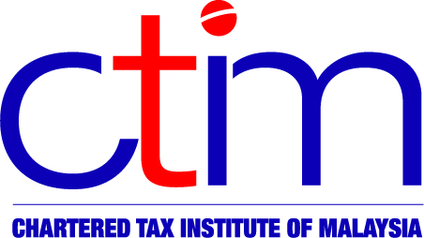
e-CIRCULAR TO MEMBERS

Chartered Tax Institute of Malaysia (225750-T)

e-CTIM No.7/2013 15 January 2013

TO ALL MEMBERS

TECHNICAL

Finance Act 2013 (Act 755) gazetted on 10 January 2013
Please be informed that the Finance Act 2013 (Act 755) was gazetted on 10 January 2013.

For details, you may view the Finance Act 2013 (Act 755) at the following link http://www.federalgazette.agc.gov.my/outputaktap/20130110_755_BI_Akta%20Kewangan%202013%20(BI).pdf

Disclaimer
This document is only meant for members of the Chartered Tax Institute of Malaysia (CTIM) only. Although the CTIM has taken all reasonable care in the preparation and compilation of the information contained in the CTIM e-circular, the Institute / each party providing the material displayed herein expressly disclaim all and any liability or responsibility to any person(s) for any errors or omissions in the contents of the CTIM e-circular or for anything done or omitted to be done by any such person in reliance whether wholly or partially, upon the whole or any part of the contents of the CTIM e-circular.

