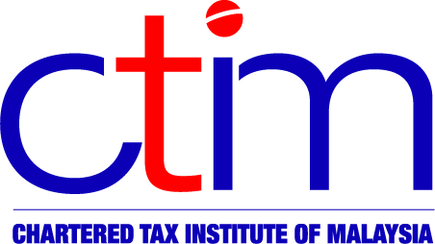
e-CIRCULAR TO MEMBERS

Chartered Tax Institute of Malaysia (225750-T)

e-CTIM No.30/2012 24 February 2012

TO ALL MEMBERS

TECHNICAL

- Filing Programme For Income Tax Return Forms (ITRF) In The Year 2012
The Inland Revenue Board (IRB) has issued the 2012 Filing Programme. The salient points to note are as follows:
- Where the due date for filing of the Income Tax Return Form (ITRF) falls during the calendar year 2012, a grace period of 15 days is granted for e-Filing. This grace period also applies to payment of balance of tax payable under subsections 103(1), 103(1A) and 103(2) of the Income Tax Act 1967, assessments issued in calendar year 2012 and debt due to the Government under Finance Act 2007 and Finance Act 2009.
- With regard to “manual filing”, a grace period of 3 working days is granted for cases where the ITRFs are sent by post; however, there is NO grace period for ITRFs filed by hand.
- Any application for an extension of time for filing and for payment of the balance of tax payable must be made to IRB separately at least 15 days before the due date for the submission of the ITRF. Each application should have strong and valid reasons and will be considered based on the merits of the case. The applications should be addressed to the Director of Policy and Operations Division, IRB at Cyberjaya.
- For companies which commenced operations after 31 December 2007, filing of Form R is not required for Year of Assessment 2010 and subsequent years.
- For refund cases only, the relevant attachments (Lampiran) and worksheets (Helaian Kerja) have to be submitted manually.

For more information members may view the 2012 Filing Programme at the IRB’s website.

- Schedule on General Issue and Submission of Income Tax Return Forms (ITRFs)
The Inland Revenue Board (IRB) has issued the above Schedule showing the date of general issue of ITRFs and the due date for submission of these ITRFs.
Members may view the schedule at the IRB’s website.

Disclaimer
This document is only meant for members of the Chartered Tax Institute of Malaysia (CTIM) only. Although the CTIM has taken all reasonable care in the preparation and compilation of the information contained in the CTIM e-circular, the Institute / each party providing the material displayed herein expressly disclaim all and any liability or responsibility to any person(s) for any errors or omissions in the contents of the CTIM e-circular or for anything done or omitted to be done by any such person in reliance whether wholly or partially, upon the whole or any part of the contents of the CTIM e-circular.

