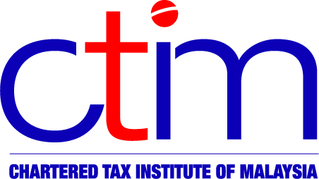
e-CIRCULAR TO MEMBERS

Chartered Tax Institute of Malaysia (225750-T)

e-CTIM No.70/2011 16 December 2011

TO ALL MEMBERS

PUBLIC PRACTICE

CTIM 2012 Budget Seminar – Recognition of CPD Points by MOF

CTIM is pleased to inform members that, further to a meeting between CTIM and the Ministry of Finance (MOF) on 9 December 2011, the MOF has confirmed in writing that the CPD points, awarded for the 2012 Budget Seminar organised by CTIM, are recognized for purposes of the approval and renewal of tax agent licence (Section 153(3), Income Tax Act,1967).

Please also note that the CPD points awarded for all other events, on direct tax matters, organized by CTIM will continue to be recognized by the MOF for purposes of the approval and renewal of tax agent licence.

Participants who are affected are advised to resubmit their application.

Disclaimer
This document is only meant for members of the Chartered Tax Institute of Malaysia (CTIM) only. Although the CTIM has taken all reasonable care in the preparation and compilation of the information contained in the CTIM e-circular, the Institute / each party providing the material displayed herein expressly disclaim all and any liability or responsibility to any person(s) for any errors or omissions in the contents of the CTIM e-circular or for anything done or omitted to be done by any such person in reliance whether wholly or partially, upon the whole or any part of the contents of the CTIM e-circular.

