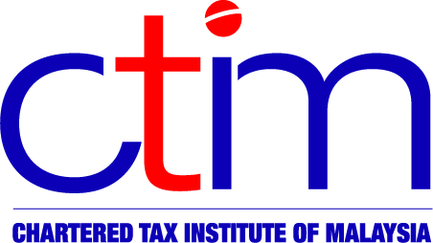
e-CIRCULAR TO MEMBERS

Chartered Tax Institute of Malaysia (225750-T)

e-CTIM No.125/2012 30 August 2012

TO ALL MEMBERS

TECHNICAL

IRB Media Release – Avoiding Offences under AMLATFA
The Inland Revenue Board (IRB) released a media statement on 29 August 2012 advising the public that the IRB will take appropriate action for tax offences under the Anti-Money Laundering and Anti-Terrorism Financing Act (AMLATFA) 2001
Anti-Money Laundering and Anti-Terrorism Financing (Amendment of Second Schedule) Order 2010 [P.U.(A) No. 343/2010], gazetted on 7 October 2010, has included the following tax offences in the Second Schedule of AMLATFA: –
- Failure to furnish return or give notice of chargeability [S. 112, Income Tax Act 1967 (ITA)];
- Submitting incorrect income tax returns [S. 113, ITA]; and
- wilful tax evasion [S.114, ITA].
Any person who is found guilty of the above offences shall be liable to a fine not exceeding RM5 million and/or jailed for up to 5 years. The IRB can freeze, seize or confiscate the person’s property during investigation. The IRB informed that in the year 2011, 1389 bank accounts had been frozen under this law. The Chief Executive Officer of the Inland Revenue Board, Tan Sri Dr. Mohd Shukor Bin Hj. Mahfar commented that the IRB is serious in implementing the law against offenders.
For further inquiries and assistance, please contact the IRB via email at callcentre@hasil.gov.my or telephone 1-300-88-3010.
Members may view the IRB Media Release at IRB’s website.

Disclaimer
This document is only meant for members of the Chartered Tax Institute of Malaysia (CTIM) only. Although the CTIM has taken all reasonable care in the preparation and compilation of the information contained in the CTIM e-circular, the Institute / each party providing the material displayed herein expressly disclaim all and any liability or responsibility to any person(s) for any errors or omissions in the contents of the CTIM e-circular or for anything done or omitted to be done by any such person in reliance whether wholly or partially, upon the whole or any part of the contents of the CTIM e-circular.

