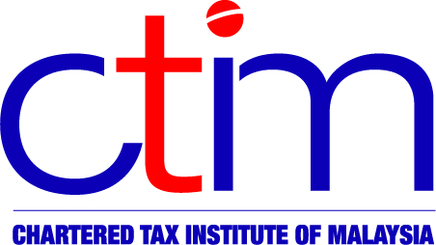
e-CIRCULAR TO MEMBERS

Chartered Tax Institute of Malaysia (225750-T)
e-CTIM TECH-IT 16/2019 5 April 2019

TO ALL MEMBERS

TECHNICAL

Indirect Taxation

Sales Tax (Amendment) Bill 2019, Service Tax (Amendment) Bill 2019, Free Zones (Amendment) Bill 2019, Customs (Amendment) Bill 2019 and Excise (Amendment) Bill 2019

The following Bills have been uploaded in the Institute’s website for your reference: -
- Sales Tax (Amendment) Bill 2019;
- Service Tax (Amendment) Bill 2019;
- Free Zone (Amendment) Bill 2019;
- Customs (Amendment) Bill 2019; and
- Excise (Amendment) Bill 2019.

The above-mentioned Bills were tabled for their first reading in the Parliament on 3 April 2019 and have been made available in the Parliament website.

The Bills may be viewed at the website of the Institute and also at the Official Portal of Parliament of Malaysia (www.parlimen.gov.my).

You may write to the Institute at technical@ctim.org.my or secretariat@ctim.org.my in respect of any suggestions, concern or comments you may have on the above Bills so that we may raise them to the RMCD. Kindly use the format of the attached template to provide your feedback/comments (if any) on or before 15 April 2019.

Disclaimer

This document is meant for the members of the Chartered Tax Institute of Malaysia (CTIM) only. CTIM has taken all reasonable care in the preparation and compilation of the information contained in this e-CTIM. CTIM herein expressly disclaims all and any liability or responsibility to any person(s) for any errors or omissions in reliance whether wholly or partially, upon the whole or any part of this e-CTIM.

