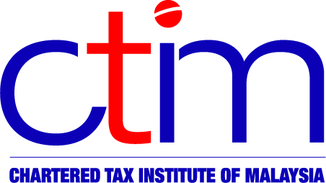
e-CIRCULAR TO MEMBERS

Chartered Tax Institute of Malaysia (225750-T)
e-CTIM TECH-DT 94/2019 27 November 2019

TO ALL MEMBERS

TECHNICAL

Direct Tax

LHDNM OPERATIONAL GUIDELINES – GUIDELINES ON PROCEDURES FOR SUBMISSION OF AMENDED RETURN FORM (GPHDN 4/2019)

The Inland Revenue Board of Malaysia (“LHDNM”) has issued a Media Release on 2 October 2019 (dated 30 September 2019) to inform that the Guidelines on Procedures for Submission of Amended Return Form (GPHDN 4/2019) (“Guidelines”) dated 30 August 2019 has been uploaded on its website.

The Guidelines replace the Operational Guidelines No. 3/2010 (GPHDN 3/2019) dated 22 April 2019 (as reported in our e-CTIM TECH-DT 37/2019 dated 8 May 2019).

Members may read the Media Release and Guidelines in full on the websites of the Institute and the LHDNM.

You may write to the Institute at technical@ctim.org.my or secretariat@ctim.org.my in respect of any suggestions, concern or comments you may have on the Guidelines so that we may raise them to the LHDNM.

Disclaimer

This document is meant for the members of the Chartered Tax Institute of Malaysia (CTIM) only. CTIM has taken all reasonable care in the preparation and compilation of the information contained in this e-CTIM. CTIM herein expressly disclaims all and any liability or responsibility to any person(s) for any errors or omissions in reliance whether wholly or partially, upon the whole or any part of this e-CTIM.

