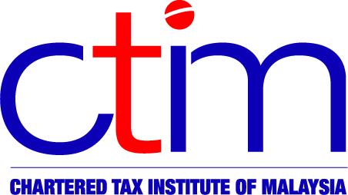**e-CIRCULAR TO MEMBERS**

**Chartered Tax Institute of Malaysia (225750-T)**

**e-CTIM TECH-DT 69/2019 27 August 2019**

**TO ALL MEMBERS**

**TECHNICAL**

**Direct Taxation**

**SCIT – Filing Appeal to High Court and Submission of Documents/Exhibits for Form Q Appeal Hearing**

The Institute received letters from the Special Commissioners of Income Tax (“SCIT”) dated 12 July 2019 and 25 July 2019 respectively as follows:-

1. [**SCIT letter dated 12 July 2019 – Filing Appeal to the High Court under Paragraph 34 of Schedule 5 of the Income Tax Act 1967**](http://www.ctim.org.my/download.asp?cat=51&file=MFHEpGDoLDsDJFrGnIoMIEKonLGMHEHI.2qs)

The [SCIT letter dated 12 July 2019](http://www.ctim.org.my/download.asp?cat=51&file=MFHEpGDoLDsDJFrGnIoMIEKonLGMHEHI.2qs) informs that the SCIT Office is required to implement e-Filing for appeal cases that are filed to the High Court under paragraph 34, schedule 5 of the Income Tax Act 1967. To smoothen the e-Filing process, parties who are aggrieved at the SCIT’s decision and file a notice of appeal under paragraph 34, schedule 5 of the Income Tax Act 1967 are required to provide and submit softcopies of the documents listed in paragraph 4 of the [letter](http://www.ctim.org.my/download.asp?cat=51&file=MFHEpGDoLDsDJFrGnIoMIEKonLGMHEHI.2qs), to the SCIT Office within two weeks after the filing date of the notice of appeal. Parties who file notice of appeal are requested to comply with this requirement immediately.

1. [**SCIT letter dated 25 July 2019 – Submission of Documents/Exhibits for Form Q Appeal Hearing**](http://www.ctim.org.my/download.asp?cat=51&file=EFqHIqnpLsIDnpDMJLsDppqGpnMJppHp.2qs)

The [SCIT letter dated 25 July 2019](http://www.ctim.org.my/download.asp?cat=51&file=EFqHIqnpLsIDnpDMJLsDppqGpnMJppHp.2qs) informs that with effect from 1 August 2019, parties are required to provide documents/exhibits in 3 copies to the SCIT Office for the purpose of the hearing.

Members may view the letters from the SCIT for more details at the [Institute’s website](http://www.ctim.org.my/news.asp?menuid=51).

**Disclaimer**

This document is meant for the members of the Chartered Tax Institute of Malaysia (CTIM) only.  CTIM has taken all reasonable care in the preparation and compilation of the information contained in this E-CTIM. CTIM herein expressly disclaims all and any liability or responsibility to any person(s) for any errors or omissions in reliance whether wholly or partially, upon the whole or any part of this E-CTIM.