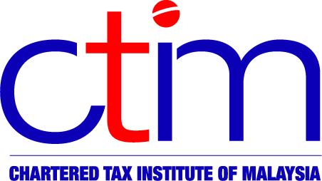**e-CIRCULAR TO MEMBERS**

**Chartered Tax Institute of Malaysia (225750-T)**

**e-CTIM TECH-DT 67/2017 18 September 2017**

**TO ALL MEMBERS**

**TECHNICAL**

**Direct Taxation**

[**PR NO. 5/2017 ON TAXATION OF REAL ESTATE INVESTMENT TRUST OR PROPERTY TRUST FUND**](http://www.ctim.org.my/download.asp?cat=14&file=sIqDoEILMnJEIMporpqMGoFoEnqnEnKF.2qs)

The Inland Revenue Board of Malaysia (LHDNM) has recently uploaded the [Public Ruling (PR) No. 5/2017 on Taxation of Real Estate Investment Trust or Property Trust Fund](http://lampiran2.hasil.gov.my/pdf/pdfam/PR5_2017.pdf) dated 8 September 2017 on its website. This PR replaces the [PR No. 2/2015](http://ctim.org.my/download.asp?cat=14&file=DGFLJ_gnAn6v10%201s%20erny%20R56n6r%20V08r56zr06%20g4756%2014%20c412r46B%20g4756%20S70q%20-%20ceF-FDEI%20(EMDJEI).2qs) dated 19 June 2015. The list of updates and amendments is found in paragraph 17 on pages 28, 29 and 30 of the [PR No. 5/2017](http://www.ctim.org.my/download.asp?cat=14&file=sIqDoEILMnJEIMporpqMGoFoEnqnEnKF.2qs).

The objective of this [PR](http://www.ctim.org.my/download.asp?cat=14&file=sIqDoEILMnJEIMporpqMGoFoEnqnEnKF.2qs) is to explain the tax treatment accorded to a real estate investment trust or a property trust fund (REIT/PTF) in Malaysia which may either be listed on Bursa Malaysia or unlisted, that is approved by the Securities Commission Malaysia (SC).

Members may read the PR in full at the websites of the [Institute](http://www.ctim.org.my/download.asp?cat=14&file=sIqDoEILMnJEIMporpqMGoFoEnqnEnKF.2qs) and the [LHDNM](http://lampiran1.hasil.gov.my/pdf/pdfam/PR5_2017.pdf).

You may write to the Institute at [technical@ctim.org.my](mailto:technical@ctim.org.my) or [secretariat@ctim.org.my](mailto:secretariat@ctim.org.my) in respect of any suggestions, concern or comments you may have on the [PR No. 5/2017](http://www.ctim.org.my/download.asp?cat=14&file=sIqDoEILMnJEIMporpqMGoFoEnqnEnKF.2qs) so that we may raise them to the LHDNM.

**Disclaimer**

This document is meant for the members of the Chartered Tax Institute of Malaysia (CTIM) only.  CTIM has taken all reasonable care in the preparation and compilation of the information contained in this E-CTIM. CTIM herein expressly disclaims all and any liability or responsibility to any person(s) for any errors or omissions in reliance whether wholly or partially, upon the whole or any part of this E-CTIM.