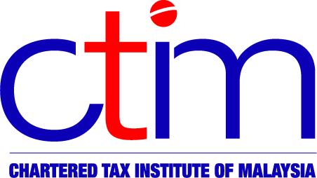**e-CIRCULAR TO MEMBERS**

**Chartered Tax Institute of Malaysia (225750-T)**

**e-CTIM Br PRK 2/2016 8 January 2016**

**TO ALL PERAK MEMBERS**

The Perak Branch is organising an Evening Talk (3.00pm – 6.00pm) on 13 January 2016 at the Ipoh City & Country Club (ICCC). The evening talk will cover the topic on Public Ruling on Advances. Click *here* for registration form and further details.

**Chak Kok Keong**

Chairman, Perak Branch

**Disclaimer**

This document is meant for the members of the Chartered Tax Institute of Malaysia (CTIM) only. CTIM has taken all reasonable care in the preparation and compilation of the information contained in this e-CTIM. CTIM herein expressly disclaims all and any liability or responsibility to any person(s) for any errors or omissions in reliance whether wholly or partially, upon the whole or any part of this e-CTIM