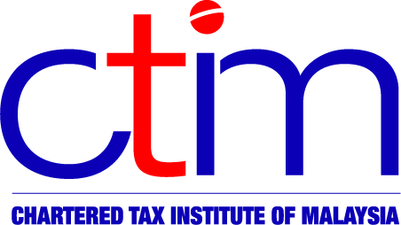
e-CIRCULAR TO MEMBERS

Chartered Tax Institute of Malaysia (225750-T)
e-CTIM GEN 14/2016 23 November 2016

TO ALL MEMBERS

MISCELLANEOUS

LHDNM REVENUE SERVICE CENTRE (RSC) IN PETALING, SELANGOR BEGINS OPERATIONS
The Inland Revenue Board of Malaysia (LHDNM) has issued a Media Release on 22 November 2016 to announce that the LHDNM Revenue Service Centre (RSC) in Petaling, Selangor will begin its operations on 1 December 2016 (Thursday).

The operating hours of the RSC will be as follows:
No | Type of Services | Operating Hours
1. | Stamp Duty | Monday – Thursday | 8.00 am - 1.00 pm
1. | Stamp Duty | Monday – Thursday | 2.00 pm – 5.00 pm
1. | Stamp Duty | Friday | 8.00 am – 12.15 pm
1. | Stamp Duty | Friday | 2.45 pm – 5.00 pm
1. | Stamp Duty | Receive Payment | Monday – Thursday  8.00 am – 1.00pm  2.00 pm – 3.30 pm  Friday  8.00 am - 12.15 pm  2.45 pm - 3.30 pm
2. | Advisory Services on Taxation, 1Malaysia People’s Aid (BR1M) & Real Property Gains Tax (RPGT) | Monday – Thursday | 8.00 am - 1.00 pm
2. |  | Monday – Thursday | 2.00 pm – 5.00 pm
2. |  | Friday | 8.00 am – 12.15 pm
2. |  | Friday | 2.45 pm – 5.00 pm
The full address of the RSC is as follows:
LEMBAGA HASIL DALAM NEGERI MALAYSIA,
PUSAT KHIDMAT HASIL PETALING,
No. D-49-G & D-50-G, Jalan Zuhal U5/178, Pusat Komersial Arena Bintang,
Seksyen U5, 40150 Shah Alam,
Selangor.
Phone : 03-77344290 / 03-77345196
Fax No. : 03-77346175

Members may view the LHDNM Media Release at the websites of the Institute and LHDNM.

Disclaimer

This document is meant for the members of the Chartered Tax Institute of Malaysia (CTIM) only. CTIM has taken all reasonable care in the preparation and compilation of the information contained in this E-CTIM. CTIM herein expressly disclaims all and any liability or any liability or responsibility to any person(s) for any errors or omissions in reliance whether wholly or partially, upon the whole or any part of this E-CTIM.

