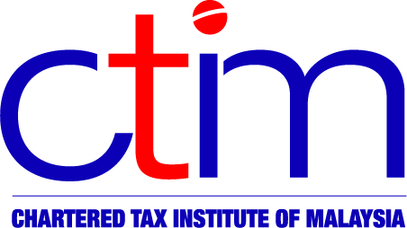
e-CIRCULAR TO MEMBERS

Chartered Tax Institute of Malaysia (225750-T)
e-CTIM TECH-IT 45/2015 21 August 2015

TO ALL MEMBERS

TECHNICAL

Indirect Taxation
OPENING OF GST KIOSK AT W.P KUALA LUMPUR AND RMCD KOTA BHARU – ANNOUNCEMENT
Further to our e-CTIM TECH-IT 43-2015, the Royal Malaysian Customs Department (RMCD) has announced the opening of the GST Kiosk in conjunction with the further extension of deadline for submission of the first GST return (quarterly taxable period) and payment as follows:

GST Kiosk | Operating Hours
W.P Kuala Lumpur  Aras 1, Block B,  Kompleks Kastam Kelana Jaya,  No.22, Jalan SS6/3,  47301 Petaling Jaya | 22 August 2015 – 23 August 2015  (Saturday – Sunday) | 8.00am - 5.00pm
RMCD Kota Bharu  JKDM Padang Bongor,  Jalan Tok Guru,  Kota Bharu, Kelantan | 21 August 2015 – 22 August 2015  (Friday – Saturday) | 8.00am – 5.00pm

Members may view the Announcement on the Institute website or on the official website of Malaysia Goods and Services Tax (GST) portal.

Disclaimer
This document is meant for the members of the Chartered Tax Institute of Malaysia (CTIM) only. CTIM has taken all reasonable care in the preparation and compilation of the information contained in this e-CTIM. CTIM herein expressly disclaims all and any liability or responsibility to any person(s) for any errors or omissions in reliance whether wholly or partially, upon the whole or any part of this e-CTIM.

