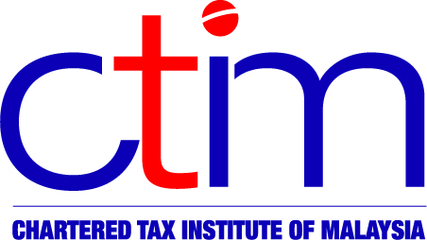
e-CIRCULAR TO MEMBERS

Chartered Tax Institute of Malaysia (225750-T)

e-CTIM TECH-DT 61/2015 6 August 2015

TO ALL MEMBERS

TECHNICAL

Direct Taxation
LHDNM Announcement -- Unapproved Institutions under Section 44(6) ITA 1967
The Inland Revenue Board of Malaysia (LHDNM) announced that the Dana CSR Kifayah Korporat untuk Amal organised by the Biro Khidmat Komuniti Pengurusan Kifayah CSR Korporat-Korporat Malaysia untuk Amal/Pertubuhan Pengurusan Pembangunan Inisiatif Pelapis Usahawan Muda Negeri Sabah is not an organisation approved under subsection 44(6) of the Income Tax Act (ITA) 1967, for not fulfilling the conditions set out in the Act.
Therefore, cash contributions to the organisation are not eligible for tax deduction under subsection 44(6) of the ITA 1967.
Members may view the announcement at the Institute website and the LHDNM website.

Disclaimer

This document is meant for the members of the Chartered Tax Institute of Malaysia (CTIM) only. CTIM has taken all reasonable care in the preparation and compilation of the information contained in this E-CTIM. CTIM herein expressly disclaims all and any liability or responsibility to any person(s) for any errors or omissions in reliance whether wholly or partially, upon the whole or any part of this E-CTIM.

