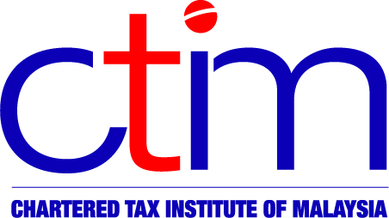
e-CIRCULAR TO MEMBERS

Chartered Tax Institute of Malaysia (225750-T)

e-CTIM No./2012 9 October 2012

TO ALL SABAH MEMBERS

2013 BUDGET SEMINAR – 24 OCTOBER 2012, HYATT REGENCY HOTEL, KOTA KINABALU
Please note that the 2013 Budget Seminar will be held on 24 October 2012, Wednesday at the Hyatt Regency Hotel, Kota Kinabalu from 9.00 am to 5.00 pm. Don’t miss the opportunity to hear the view points of the Inland Revenue Board of Malaysia (IRBM).

Session | Chairman | Speaker | Panelist
Summary of 2013 Budget Proposals | Ms Alexandra Chin  Sabah Branch Chairman | Madam Zaleha Adam, Director, Drafting & Law Revision Division, IRBM | NA
Forum Discussion and  Q & A Session: 2013 Budget Tax Proposals – Highlights& Implications | Ms Alexandra Chin  Sabah Branch Chairman | NA | Madam Zaleha Adam, Director, Drafting & Law Revision Division, IRBM  Dr Nakha Ratnam Somasundaram  CPD Committee Member, CTIM
Tax Updates & Latest Developments | Ms Viviana Lim  Branch Committee Member | Local Tax Practitioner | NA
Panel Discussion on Tax Audits | Ms Angeline Wong Yu Ching  Deputy Branch Chairman | NA | Dr Nakha Ratnam Somasundaram  CPD Committee Member, CTIM  Local Tax Practitioner
Click HERE for the registration form. [10 CPD Points]
For more information, kindly contact CPD Secretariat as follows:
Tel : 03-2162 8989
Fax : 03-2162 8990 / 03-2161 3207
Website: www.ctim.org.my

Ms Fadeah | ext 113 | fadeah@ctim.org.my
Ms Yus | ext 121 | yusfariza@ctim.org.my
Mr Jason | ext 108 | jason@ctim.org.my
Ms Ally | ext 123 | ally@ctim.org.my
Ms Nur | ext. 106 | nur@ctim.org.my

Disclaimer
This document is only meant for members of the Chartered Tax Institute of Malaysia (CTIM) only. Although the CTIM has taken all reasonable care in the preparation and compilation of the information contained in the CTIM e-circular, the Institute / each party providing the material displayed herein expressly disclaim all and any liability or responsibility to any person(s) for any errors or omissions in the contents of the CTIM e-circular or for anything done or omitted to be done by any such person in reliance whether wholly or partially, upon the whole or any part of the contents of the CTIM e-circular.

